**Semiconductors**

Semiconductors are divided into intrinsic and extrinsic semiconductors depending on the structure properties.

Intrinsic Semiconductors.

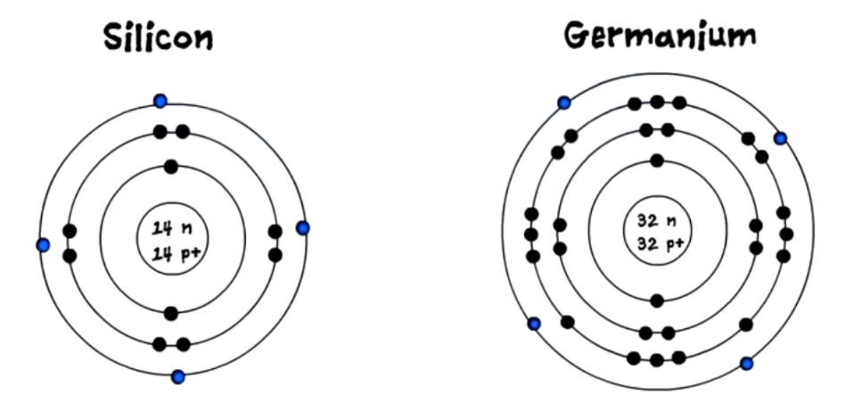Intrinsic semiconductors to ignore what intrinsic means it means in its purest form, therefore these type of semiconductors are in the purest form by the nature of their existence.

The common semiconductors used are silicon and germanium, and they have four valence electrons orbiting in its outermost shell.

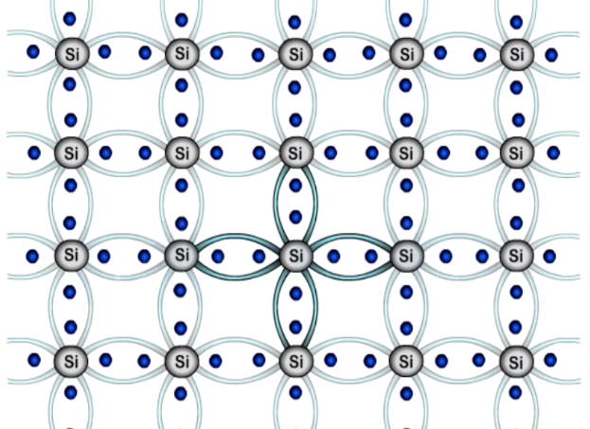We can further understand the motion of these electrons by looking at the structure of its atom. However the atom needs a total of 8 electrons in its outer shell to become stable.

Now let's see how the semiconductor atom acquires the additional four electrons and become stable. Let's first look at this process with the help of one atom this atom already has its four valence electrons and requires an additional four to become stable, which it shares with its neighboring atoms, so that every silicon atom has eight electrons in its outer shell.

Millions of silicon atoms are bonded together and they form a semiconductor structure which looks like this. All these atoms set up a bond with each other which is called as a covalent bond. However these bonds are so strong that the electron fails to break the bond at zero Kelvin, but as the temperature increases the electron absorbs the heat energy and it is able to break the bond.

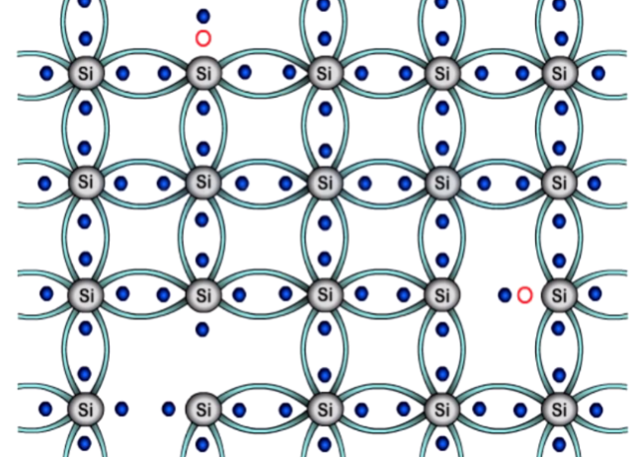Once the bond is broken the electron becomes free to carry the current. We get a deficiency of an electron in the structure, and there is an empty space formed, which can also refer to as a hole. Therefore we consider holes to be positively charged electron.

The electron is negative and the empty space or hole is positive, therefore the immediate neighboring electron gets attracted towards this hole and fills its place thus creating another empty space or hole in its previous position. The process will continue in the entire structure in a random manner.